Type of the Article (Research Article / Review / Editorial / Protocol / Systematic Review / Protocol)
Title of the Research Article (The title must precisely reflect the scope and content of your paper. Avoid misleading or exaggerated claims)

Author Name ¹, Author Name ², Author Name ³ and Author Name ³ *

Received: 20Dec2025; Revised: 25Dec2025; Accepted: 01Jan2026; Published: 01Jan2026
_____________________________________________________________________________________________________________________________________________________________

Example Graphical Abstract

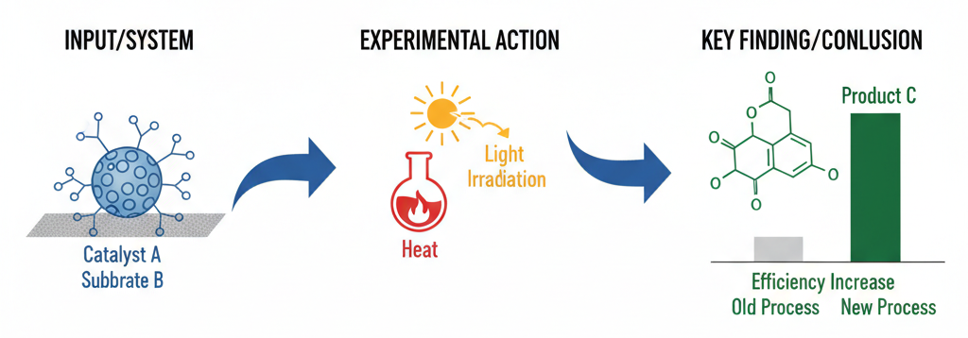

___________________________________________________________________________________________________________________________________________

Graphical Abstract
A Graphical Abstract (GA) is a single, concise, visual summary of the main finding, message, or process described in a research article. It helps readers quickly grasp the essence of the work and encourages them to read the full article.
Here are the detailed guidelines for preparing and submitting a Graphical Abstract for Unig Science.

General Design Principles
The GA must be visually clear and communicate the core message at a glance. Avoid excessive detail or clutter.
It should represent the main finding or process without requiring additional text (beyond labels within the figure itself).
Center the design on the novelty and key conclusion of the paper.

Technical Specifications
File Format: TIFF, JPEG, PDF.
Size/Dimensions: Aspect Ratio: Typically a horizontal rectangle (landscape). Common dimensions are 1200×600 pixels.
Resolution: Minimum 300 dots per inch (dpi).
Colour Mode: Ensure colours are distinct and accessible (avoid relying on colour alone for meaning).
Font: Book Antiqua or clear font. Keep font sizes consistent and large enough to read easily.

Content and Components
The GA should typically include 3–5 key elements:
Main Subject/System: The material or system being studied (e.g., a specific molecule, a biological cell, a device).
Experimental Method/Action: The process or intervention being applied (e.g., a chemical reaction, heating, observation).
Key Result/Outcome: The most significant finding or change observed.
Connecting Elements: Use arrows, lines, or icons to show the relationship and flow between the components.
Labels (Minimal): Only essential text labels for components, chemical formulas, or key numbers.
Crucial Note: Do not simply include a figure taken directly from the manuscript. The GA must be a new, distilled summary.

Review and Submission Checklist
Authors should ensure the following before submission:
The GA adheres to all technical specifications (format, size, resolution).
The visual accurately reflects the content and conclusion of the abstract and manuscript.
The GA is the author's original work or utilizes elements for which they have secured necessary permissions.
The text labels are legible, and the flow is easy to follow.

The GA conveys the core message without needing the full text abstract.
Note: The Graphical Abstract will be displayed on the journal website immediately upon paper acceptance.
___________________________________________________________________________________________________________________________________________

